SQL Practice Questions

**QUE 1**

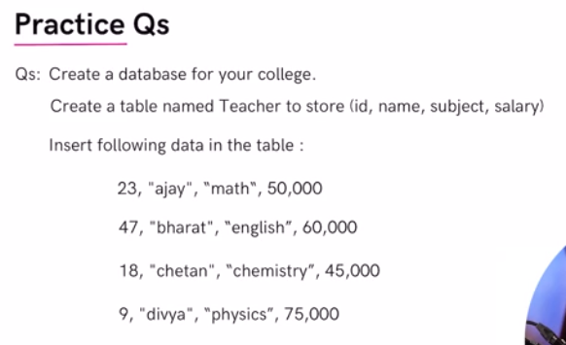



SHOW DATABASES;

CREATE DATABASE college;

USE college;

CREATE TABLE IF NOT EXISTS teacher(

id INT PRIMARY KEY,

name VARCHAR(30),

subject VARCHAR(20),

salaray DOUBLE

);

SELECT * FROM teacher;

ALTER TABLE teacher

CHANGE COLUMN salaray salary DOUBLE;

INSERT INTO teacher (id, name, subject, salary)

VALUES (23, "ajay", "math", 50000),

(47, "bharat", "english", 60000),

(18, "chetan", "chemistry", 45000),

(9, "divya", "physics", 75000);

SELECT * FROM teacher

WHERE salary > 55000;

-- Rename Column--

ALTER TABLE teacher

CHANGE COLUMN salary ctc INT;

SELECT * FROM teacher;

-- Update Column--

UPDATE teacher

SET ctc = ctc*1.25;

-- Add Column --

ALTER TABLE teacher

ADD city VARCHAR(20) DEFAULT "Gurgaon";

-- Delete Column--

ALTER TABLE teacher

DROP COLUMN city;

**QUE 2**

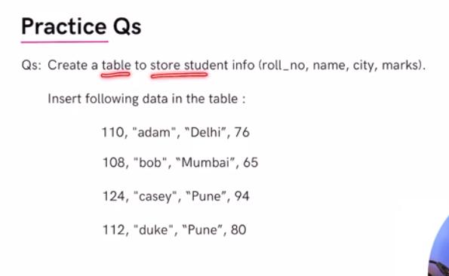

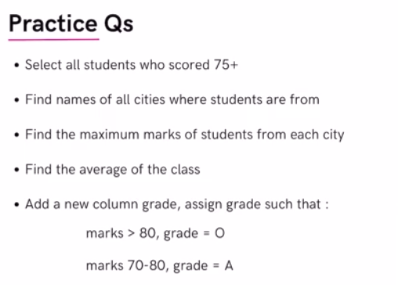

USE college;

CREATE TABLE IF NOT EXISTS student(

roll_no INT PRIMARY KEY,

name VARCHAR(20),

city VARCHAR(30),

marks DOUBLE DEFAULT 0

);

INSERT INTO student (roll_no, name, city, marks)

VALUES

(110, "adam", "Delhi", 76),

(108, "bob", "Mumbai", 65),

(124, "casey", "Pune", 94),

(112, "duke", "Pune", 80);

SELECT * FROM student;

SELECT * FROM student

WHERE marks > 75;

SELECT city FROM student

GROUP BY city

ORDER BY city;

SELECT city, max(marks) FROM student

GROUP BY city

ORDER BY Max(marks) DESC;

SELECT AVG(marks) FROM student;

ALTER TABLE student

ADD COLUMN grade CHAR(1);

UPDATE student

SET grade = "B" WHERE marks <70;

UPDATE student

SET grade = 'A' WHERE marks BETWEEN 70 AND 80;

UPDATE student

SET grade = 'O' WHERE marks>=80;

SELECT * FROM student;